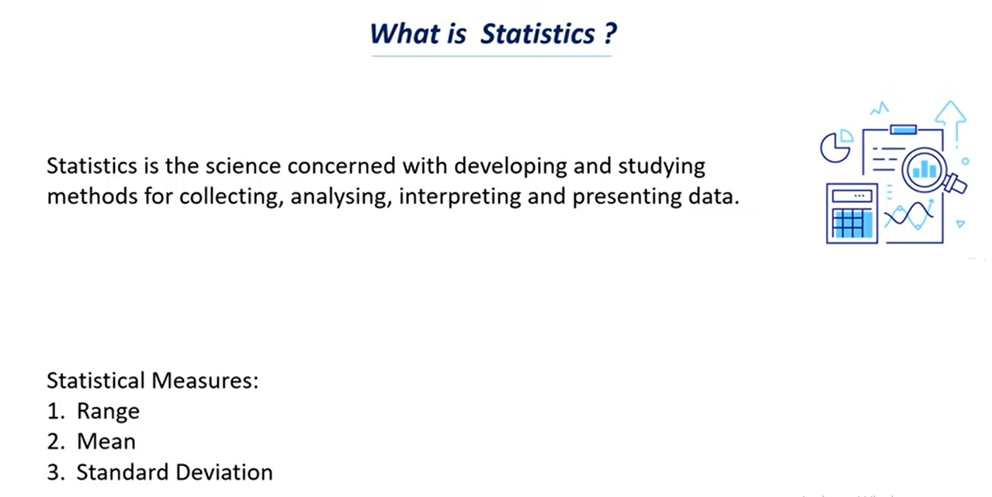

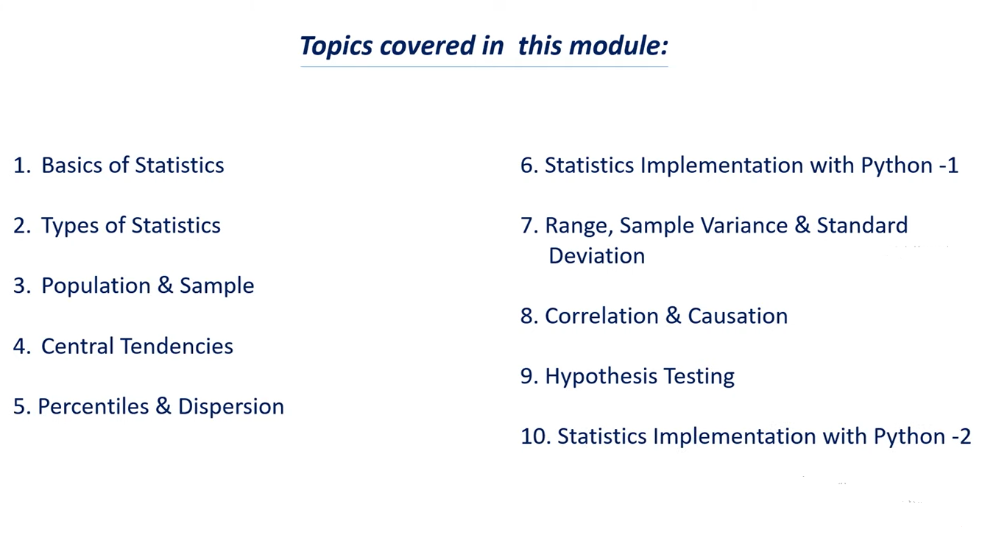

**Basic 0f Statistics:**

1. Why we need statistics
2. Applications of statistics
3. Types of Data

**Why we need statistics or what is the importance of statistics**

Statistics is a tool that helps us to extract information and knowledge from data

Lets say that we have data and this statistical measure or this statistical technique can help us to find what is the significant of this data.

Avg is nothing but mean

Mean = All the observation / total no. of observation.

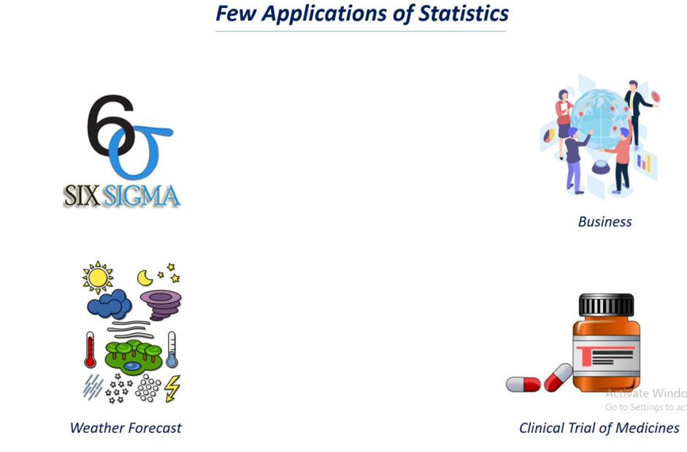

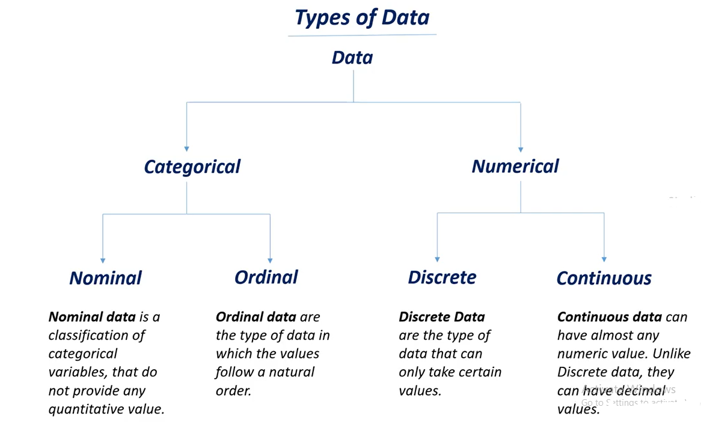

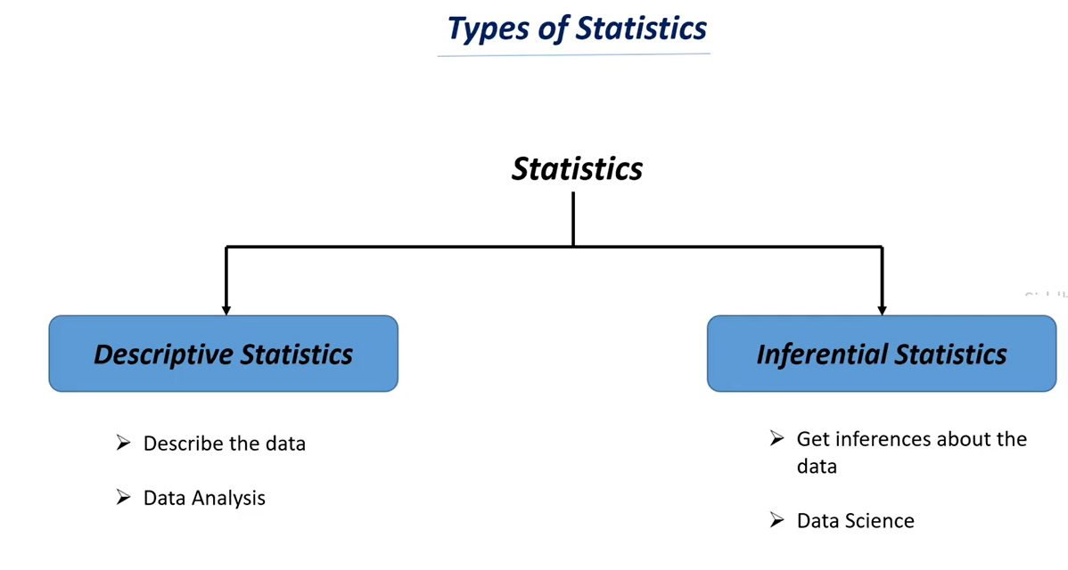

* **Descriptive statistics** means giving some description or giving some summarization to the data.
* **Inferential statistics** means finding some inferences from the data and finding insights from the data and we also try to predict future cases.

**Descriptive statistics Example: There is data analysis to analysis there previous year’s sales and analysis can go through the sales data and find’s some interesting insights from the data like profit, loss from the data.**

**In case of descriptive statistics we use some numerical measures from the data.**

**Whereas data scientist do is he can use the data and try’s to find the insights from the data or find the inferences from the data based on these inferences he can suggest the management of the company to obtain various strategies to increase profit percentage.**

